**Title:** BCS I Waste heat recovery technology and opportunities in US industry

**Author(s):** BCS, Incorporated

**Published:** US Department of Energy, 2008

**Keywords:**

From the executive summary: “This report investigates industrial waste heat recovery practices, opportunities nd barriers in order to identify technology research, development, and demonstration (RD&D) needed to enable further recovery of industrial waste heat losses… RD&D opportunities include optimizaing existing recovery technologies as well as developing new heat recovery technologies. Existing technologies can be further improved to maximize recovery, expand application constraints, and improve economic feasibility. Emerging and novel technologies may hold promise for replacing existing technologies in some cases, enabling heat recovery from ‘new’ heat sources not typically considered for recovery, and increasing ‘end-use’ options for heat recovery.”

The approach this study takes is probably a good one for my study in that it estimates the quantity of energy in a given heat source, the quality of that heat, and the recovery technologies, practices and barriers present with that application.

This study found that “most unrecovered waste heat is at low temperatures.” Which is to say that it is less than 450oC above ambient temperatures.

This study noted the Kalina cycle for its recent developmental success in recovering energy from low temperature applications.

Some of the barriers to the development of low temperature waste heat recovery noted were:

1. Long payback periods
2. Material constraints and costs
3. Economies of scale (Waste heat recovery does not lend itself well to a general solution)
4. Operation and maintenance costs. – Corrosion, scaling, and fouling of heat exchange materials lead to higher maintenance costs and lost productivity.

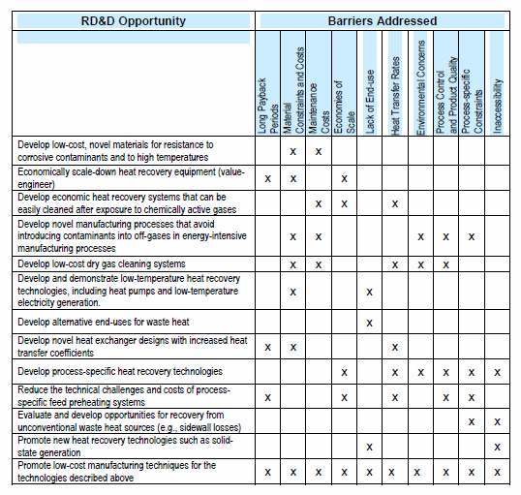

Figure : Research, Development, and Demonstration Needs for Addressing - Waste Heat Recovery Barriers

Heat quantity:

$$\dot{E}=\dot{m}h(t)$$

Waste heat loss (Btu/hr) is equal to the mass flow rate (lb/hr) multiplied by the stream specific enthalpy (Btu/lb) as a function of temperature.

Heat Quality:

High: 1,200+ oF

Medium: 450oF - 1,200 oF

Low: 450-oF

Heat exchanger area requirements:

$$\dot{Q}=UAΔT$$

Where Q is the heat transfer rate; U is the heat transfer coefficient; A is the surface area for heat exchange; and ΔT is the temperature difference between the two streams.

Temperature and material selection:

“The temperature of the waste heat source also has important ramifications for material selection in heat exchangers and recovery systems. Corrosion and oxidation reactions, like all chemical reactions, are accelerated dramatically by temperature increases.”